

VLSI DESIGN PROJECTS/INTERNSHIP

# College Name

* **SRM Institute of Science and Technology.**

# Company Name

* **Vyorius.**

# Domain

* **VLSI design.**

### Project topics

### Basic circuits written in Verilog/VHDL, simulated and implemented on the FPGA

### UART communication to print a single character

### FSM Designs: Mealy & Moore Machines and Up Down Counter

**Hardware and software used**

**Hardware,**

# Mimas A7 Mini FPGA Development Board

Mimas A7 Mini is an easy-to-use FPGA Development board featuring Artix 7 FPGA (XC7A35T – FTG256C package) with FTDI’s FT2232H Dual-Channel USB device. It is an Artix-7 based replacement and upgrades of Mimas Spartan 6 FPGA Board. It is specially designed for the development and integration of FPGA based accelerated features to other designs. The USB 2.0 host interface based on popular FT2232H offers high bandwidth data transfer and board programming without the need for any external programming adapters.

**Features,**

* Device: Xilinx Artix 7 FPGA (XC7A35T-1FTG256C)
* DDR3: 2Gb DDR3 (MT41J128M16JT-125 or equivalent)
* Built-in programming interface. No expensive JTAG adapters needed for programming the board
* Onboard 128Mb flash memory for FPGA configuration storage and custom user data storage
* High-Speed USB 2.0 interface for On-board flash programming. FT2232H Channel B is dedicated to JTAG Programming. Channel A can be used for custom applications
* 100MHz CMOS oscillator
* 8 LEDs, 1 RGB LED and 4 Push Buttons for user-defined purposes
* FPGA configuration via JTAG and USB
* Maximum IOs for user-defined purposes

FPGA – 70 IOs (35 professionally length matched Differential Pairs) and two 2×6 Expansion Headers

**Applications,**

* Product Prototype Development
* Accelerated computing integration
* Development and testing of custom embedded processors
* Communication devices development
* Educational tool for Schools and Universities

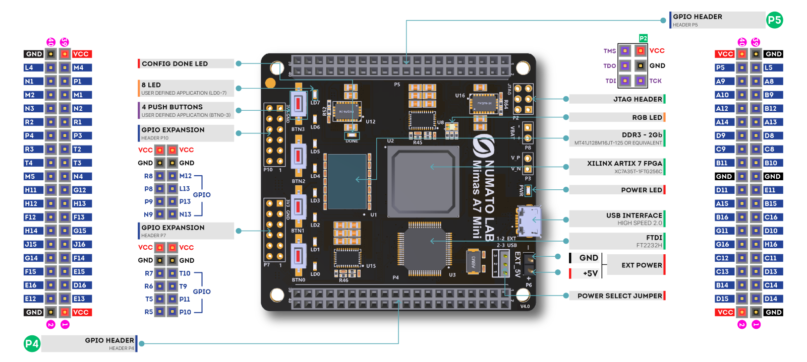

#### **Specifications,**

|  |  |
| --- | --- |
| Attribute | Value |
| **Dimensions** | 6 × 4 × 1 in |
| **FPGA** | [**XC7A35T – 1FTG256C**](https://numato.com/fpga/xc7a35t-1ftg256c/) |
| **Memory** | [**DDR3 – 2Gb**](https://numato.com/memory/ddr3-2gb/) |
| **Configuration Options** | [**JTAG**](https://numato.com/configuration-options/jtag/), [**USB**](https://numato.com/configuration-options/usb/) |
| **Host Interface** | [**USB 2.0**](https://numato.com/host-interface/usb-2-0/) |
| **Primary Clock Frequency** | [**100MHz**](https://numato.com/primary-clock-frequency/100mhz/) |
| **Number Of GPIOs (Max)** | [**70**](https://numato.com/number-of-gpios/70/) |
| **Number Of Diff Pairs** | [**35**](https://numato.com/number-of-diff-pairs/35/) |

**Software**



*Icarus Verilog* is a Verilog simulation and synthesis tool. It operates as a compiler, compiling source code written in Verilog (IEEE-1364) into some target format. For batch simulation, the compiler can generate an intermediate form called *vvp assembly*. This intermediate form is executed by the ``vvp'' command. For synthesis, the compiler generates netlists in the desired format.

The compiler proper is intended to parse and elaborate design descriptions written to the IEEE standard *IEEE Std 1364-2005.* This is a fairly large and complex standard, so it will take some time to fill all the dark alleys of the standard, but that's the goal.

*Icarus Verilog* is a work in progress, and since the language standard is not standing still either, it probably always will be. That is as it should be. However, I will make stable releases from time to time, and will endeavour to not retract any features that appear in these stable releases. The quick links above will show the current stable release.

The main porting target is Linux, although it works well on many similar operating systems. Various people have contributed precompiled binaries of stable releases for a variety of targets. These releases are ported by volunteers, so what binaries are available depends on who takes the time to do the packaging. *Icarus Verilog* has been ported to That Other Operating System, as a command line tool, and there are installers for users without compilers. You can compile it entirely with free tools, too, although there are precompiled binaries of stable releases.



**Vivado Design Suite** is a software suite produced by [Xilinx](https://en.wikipedia.org/wiki/Xilinx) for synthesis and analysis of [HDL](https://en.wikipedia.org/wiki/Hardware_description_language) designs, superseding [Xilinx ISE](https://en.wikipedia.org/wiki/Xilinx_ISE) with additional features for [system on a chip](https://en.wikipedia.org/wiki/System_on_a_chip) development and [high-level synthesis](https://en.wikipedia.org/wiki/High-level_synthesis).[[1]](https://en.wikipedia.org/wiki/Xilinx_Vivado#cite_note-Xilinx-Inc-Apr-2012-8-K-1)[[5]](https://en.wikipedia.org/wiki/Xilinx_Vivado#cite_note-5)[[6]](https://en.wikipedia.org/wiki/Xilinx_Vivado#cite_note-hls1-6)[[7]](https://en.wikipedia.org/wiki/Xilinx_Vivado#cite_note-7) Vivado represents a ground-up rewrite and re-thinking of the entire design flow (compared to ISE).[[8]](https://en.wikipedia.org/wiki/Xilinx_Vivado#cite_note-8)[[9]](https://en.wikipedia.org/wiki/Xilinx_Vivado#cite_note-9)[[10]](https://en.wikipedia.org/wiki/Xilinx_Vivado#cite_note-10)

Like the later versions of [ISE](https://en.wikipedia.org/wiki/Xilinx_ISE), Vivado includes the in-built logic simulator [ISIM](https://www.xilinx.com/products/design-tools/isim.html).[[11]](https://en.wikipedia.org/wiki/Xilinx_Vivado#cite_note-11) Vivado also introduces high-level synthesis, with a toolchain that converts C code into programmable logic.[[6]](https://en.wikipedia.org/wiki/Xilinx_Vivado#cite_note-hls1-6)

Replacing the 15-year-old ISE with Vivado Design Suite took 1000 [person-years](https://en.wikipedia.org/wiki/Person-years) and cost US$200 million.



Tenagra is an FPGA System management tool for configuring and communicating with Numato Lab’s supported FPGA modules and development platforms. This software is designed to be a single interface for managing the devices and exercising some of the available features. Currently, Tenagra supports configuring the FPGA module/board (programming) and Memory Exerciser that can transfer data between various memories on the device. This includes both external DDR Memory and Block RAM available within the FPGA device. With Tenagra, you can create multiple configuration setups with different bitstreams and settings for each device model so that switching between multiple bitstreams is a breeze. This is especially helpful during development where the device may need to be reprogrammed with various bitstreams repeatedly.

**Driver for Mimas A7 Mini Module**



PuTTY is a free implementation of SSH **(and telnet) for PCs running Microsoft Windows** (it also includes an xterm terminal emulator). You will find PuTTY useful if you want to access an account on a Unix or other multi-user system from a PC (for example your own or one in an internet cafe).

2. UART communication to print a single character

**Software to download**

* Notepad++

Step 1- Write the verilog program in notepad ++ .

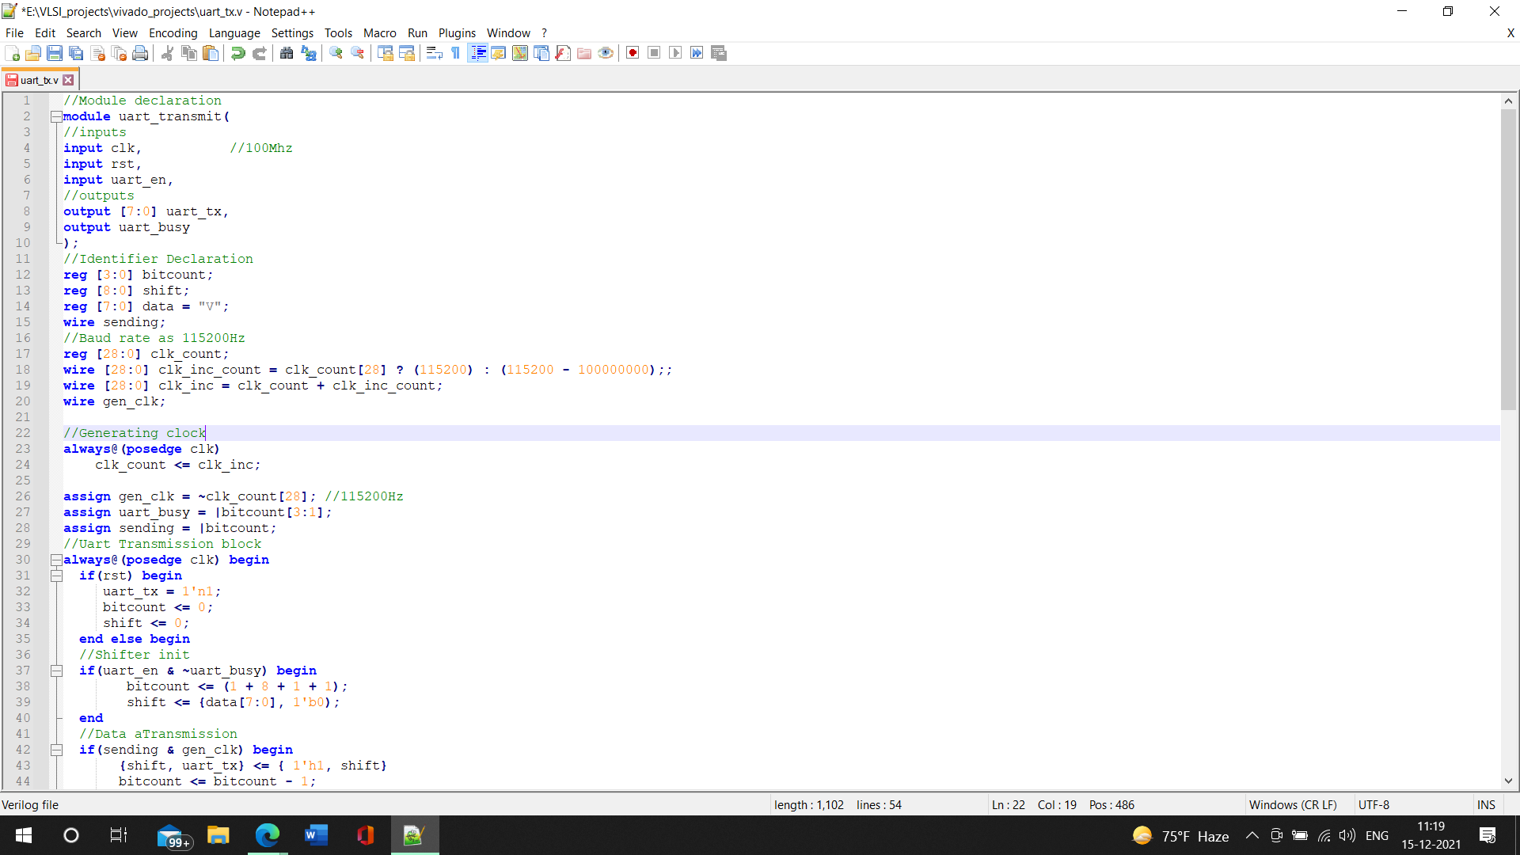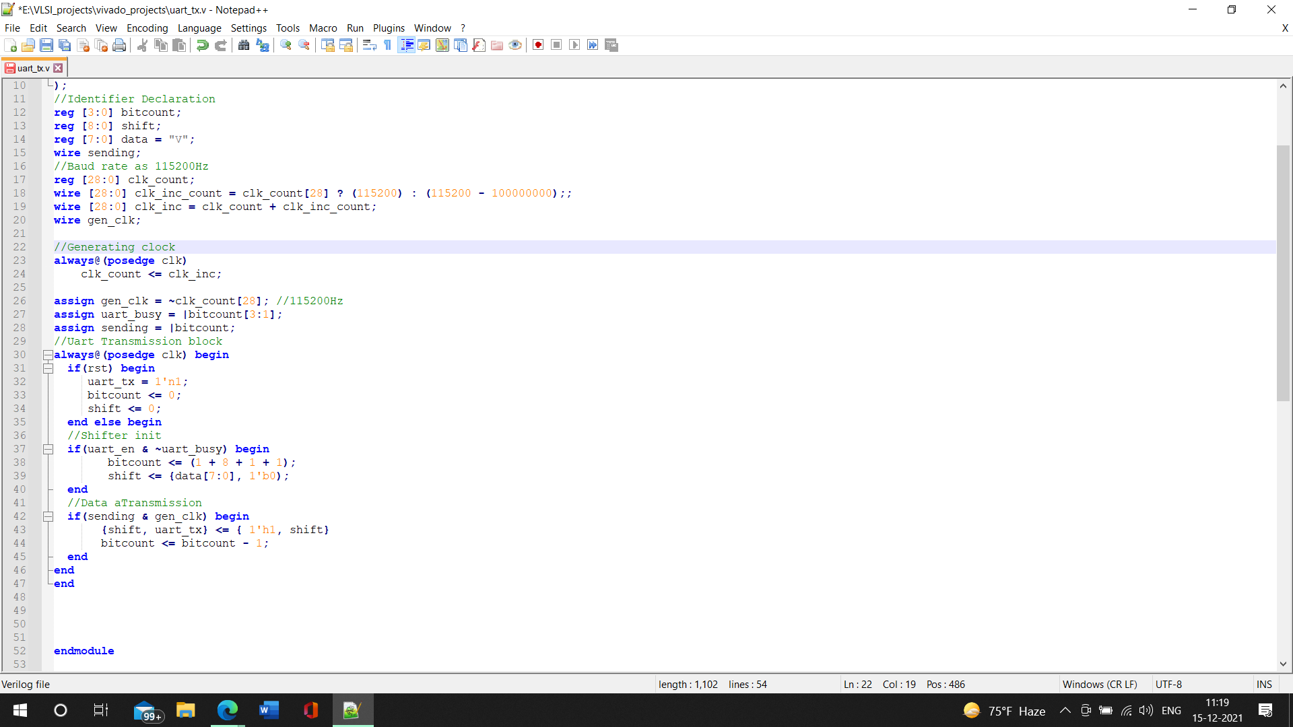

Step 2-Open Vivado software create a new project and add this notepad verilog extension to it

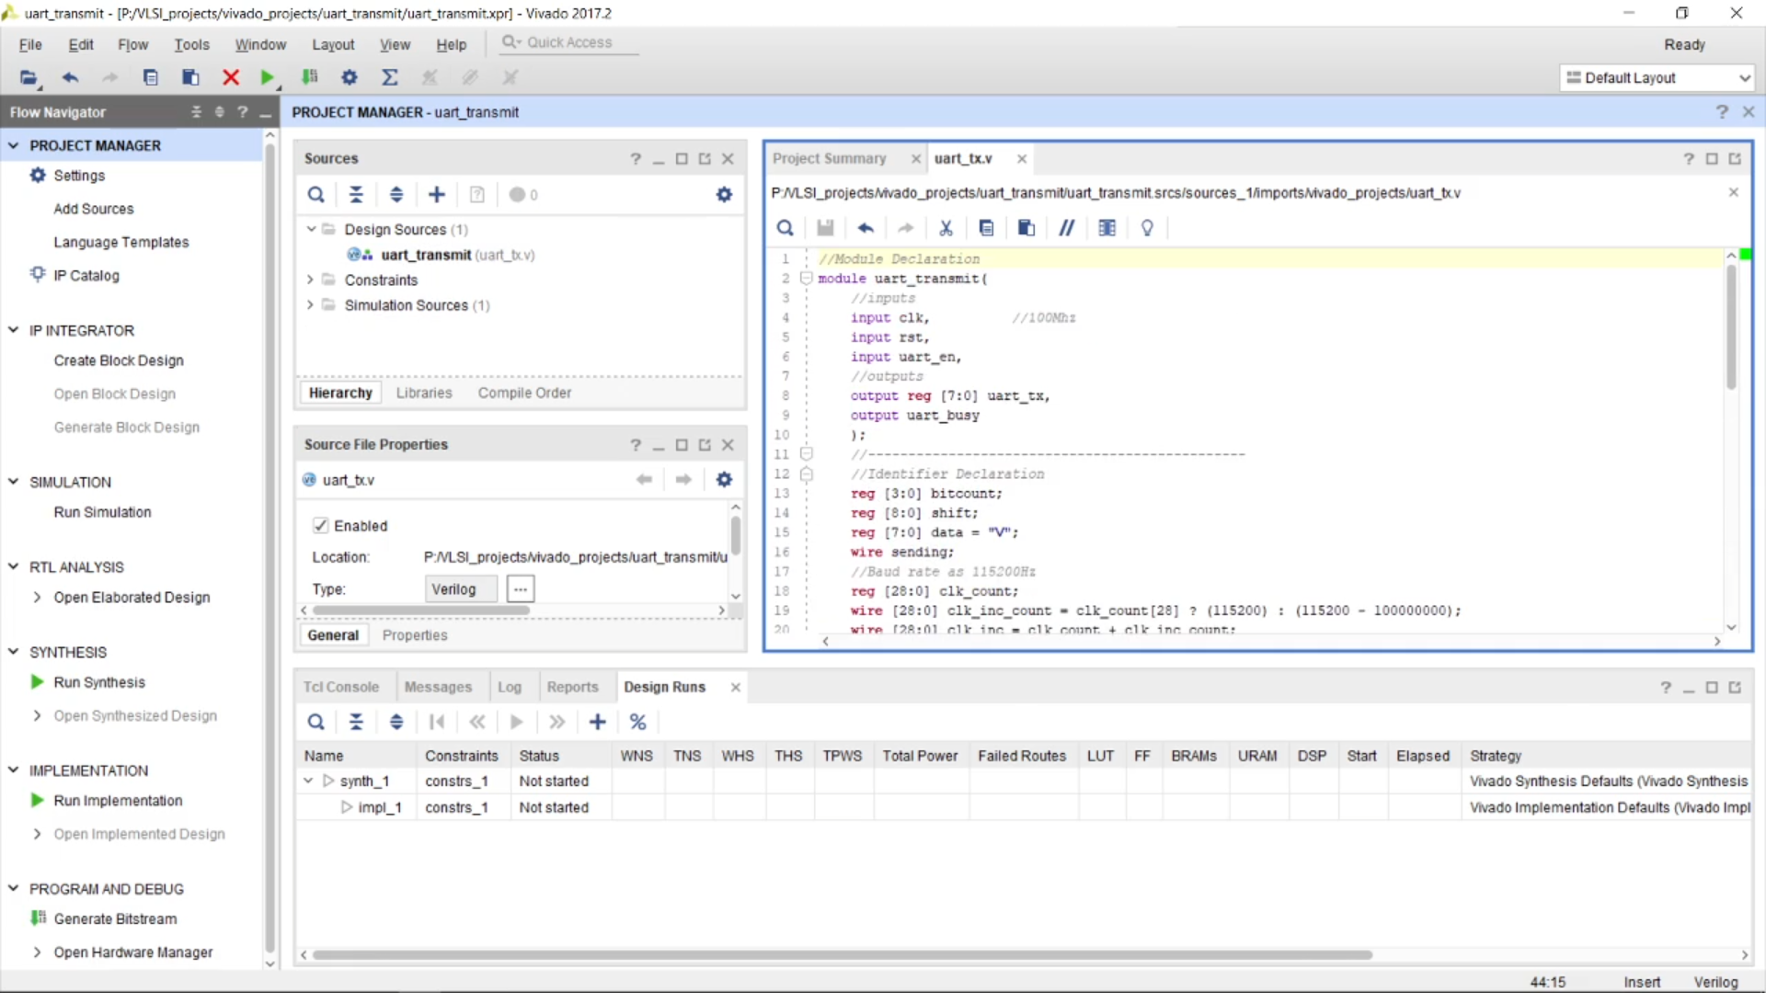Synthesis the code extracted and compile the errors if there are any.

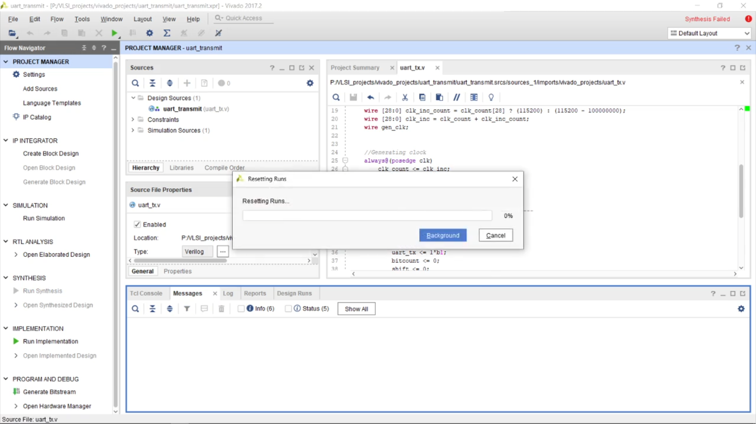After synthesis run implementation

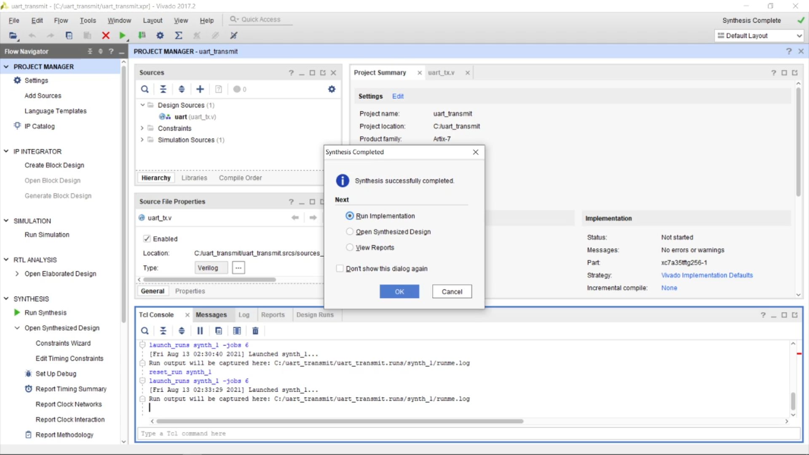Open synthesis implemented design

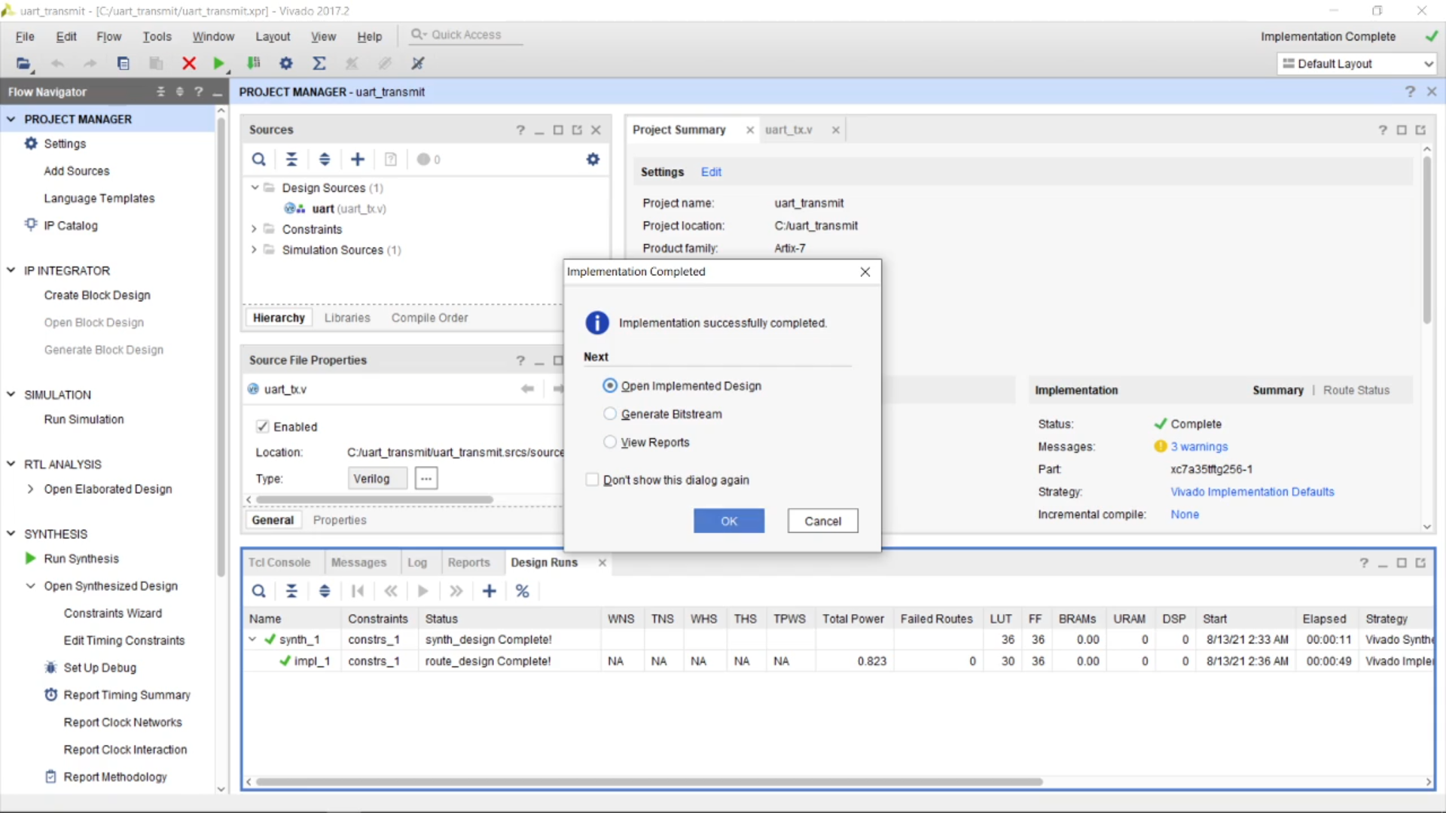Now one of the most vital part we have to change port design with respect to the XDC file we got for vivado designs from the link [Mimas A7 Mini FPGA Development Board | Numato Lab](https://numato.com/product/mimas-a7-mini-fpga-development-board/)

After downloading it open up with the notepad where we can view the XDC file

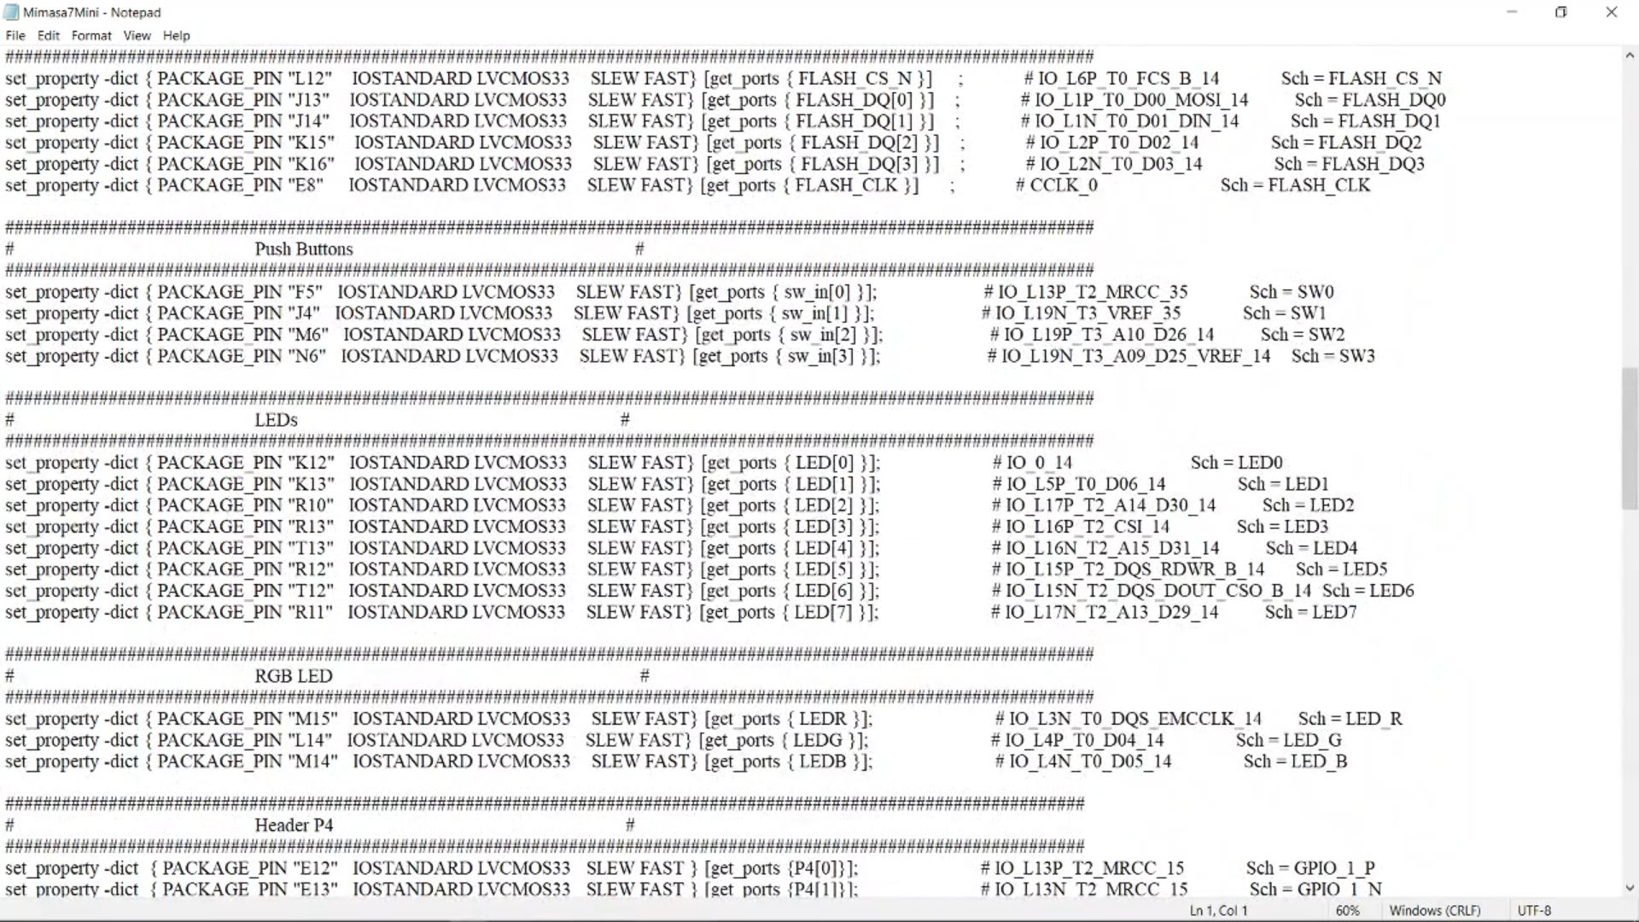

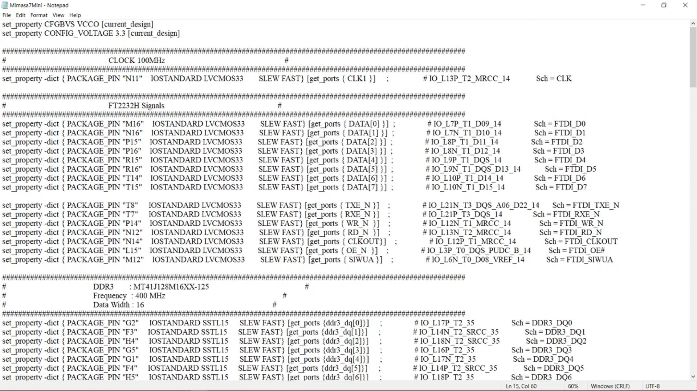

And have the necessary requirements, and when I say requirements, we need many ports for signals( user and programmimg chaneel), clock, Mimas A7 Mini does not have any reset we will use the push button pins,LED

We will use low voltage CMOS, LVCMOS33

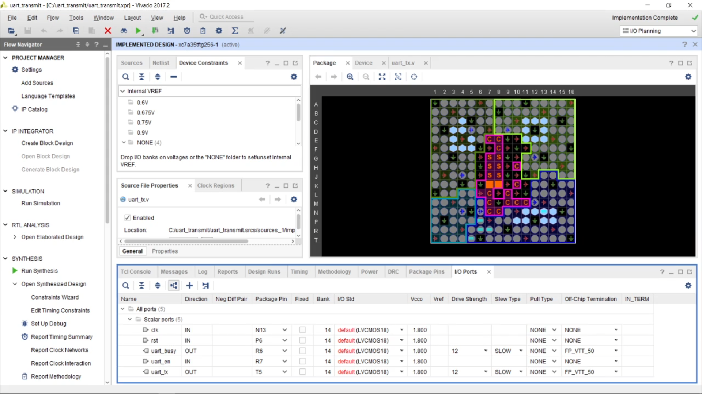

After the necessary changes save it and name the file as “uart_tx”

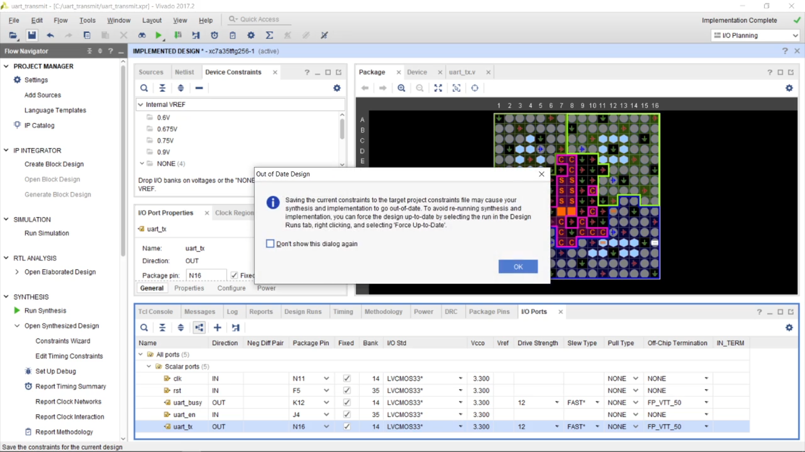

After that we can see in the source file under constrains and the I/O standards are given

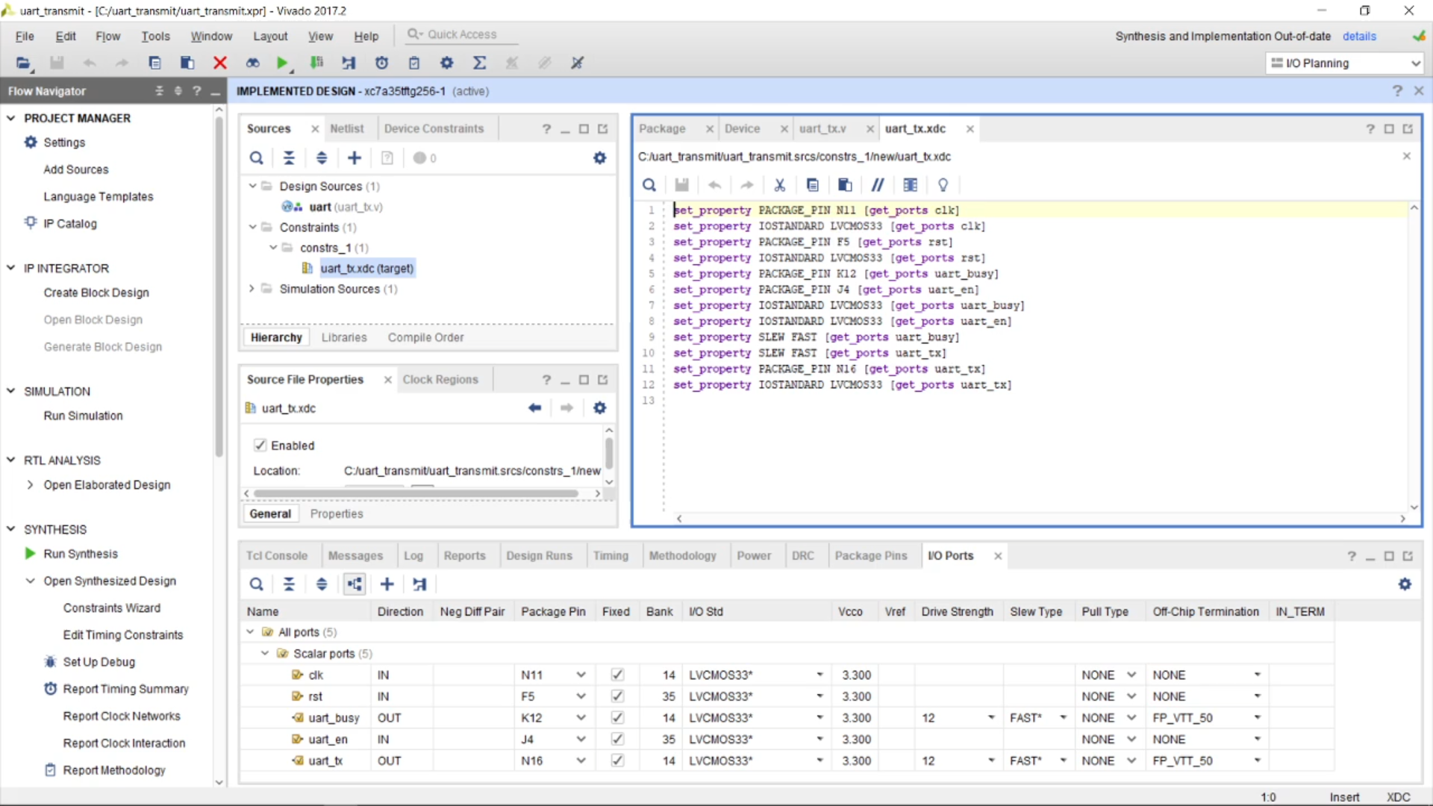Generate bit stream after that, resulting in synthesis and implementation

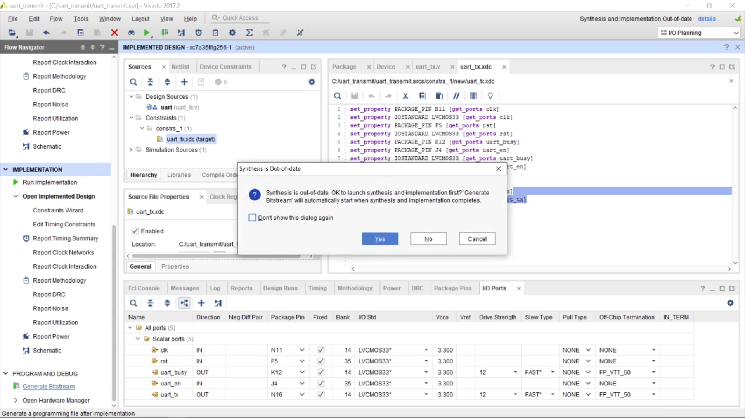

After the generation of bit stream open hardware manager

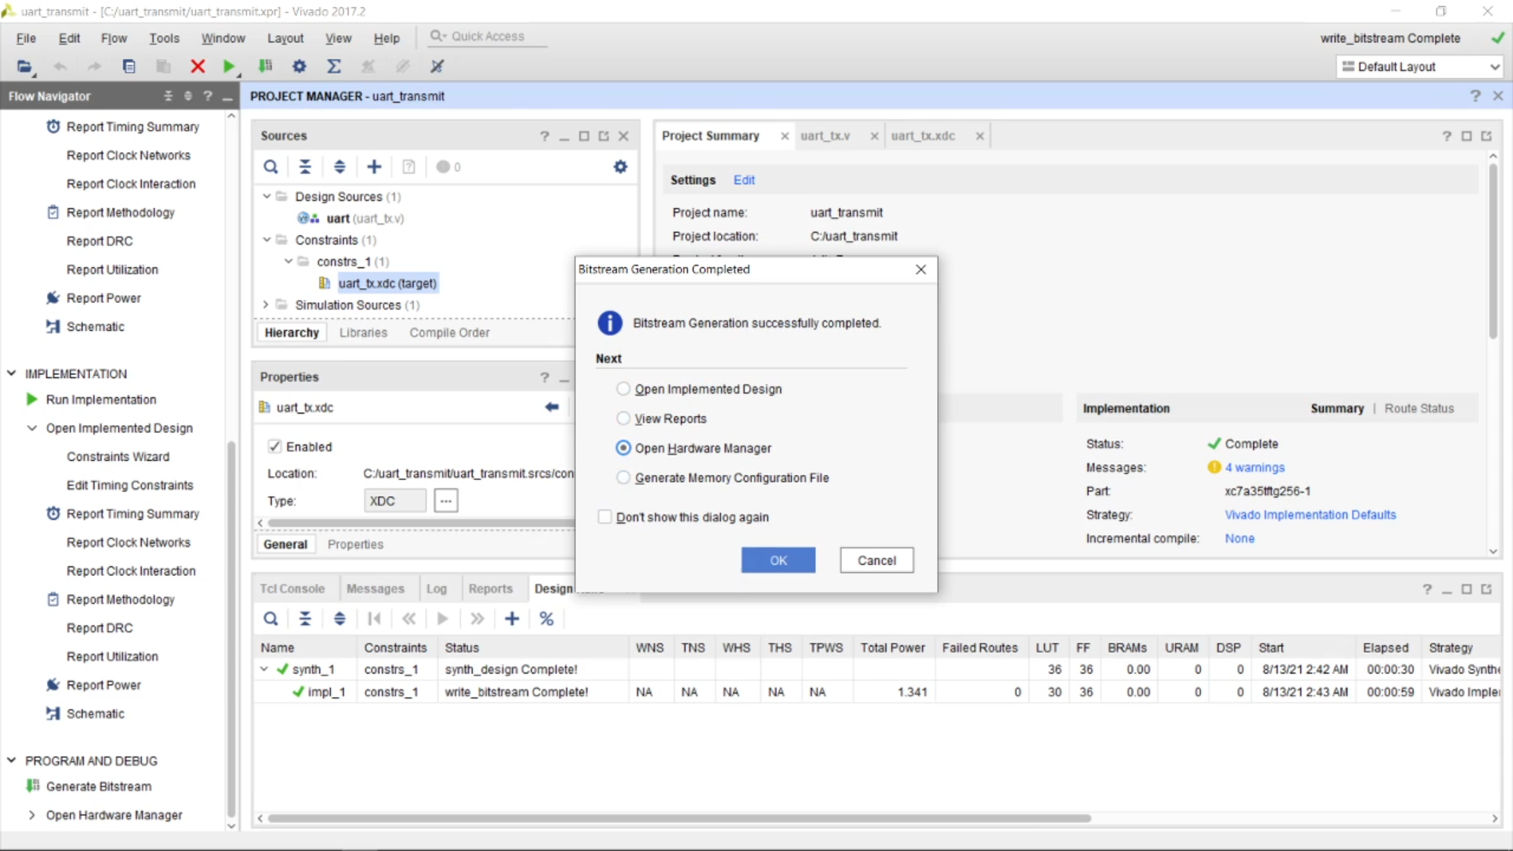Step 3- Download a serial monitor , we will be using a light weight serial monitor software

[Download PuTTY - a free SSH and telnet client for Windows](https://www.putty.org/) link to download

After that launch Putty with a a serial line as “COM 4” shown in device manager used in the following case , and the speed we know set as 15200, and then open the termnal.

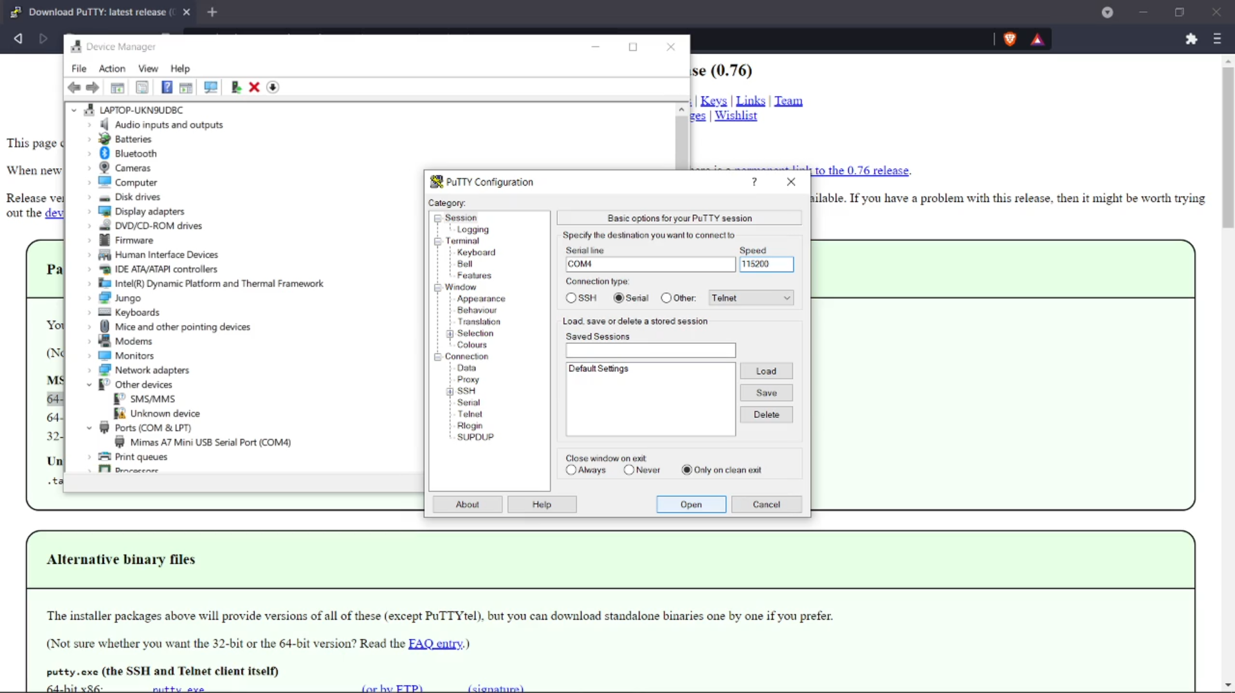Step 4- Open Tenegra application and synch vivado bitstream file , you can go to setting and create one .

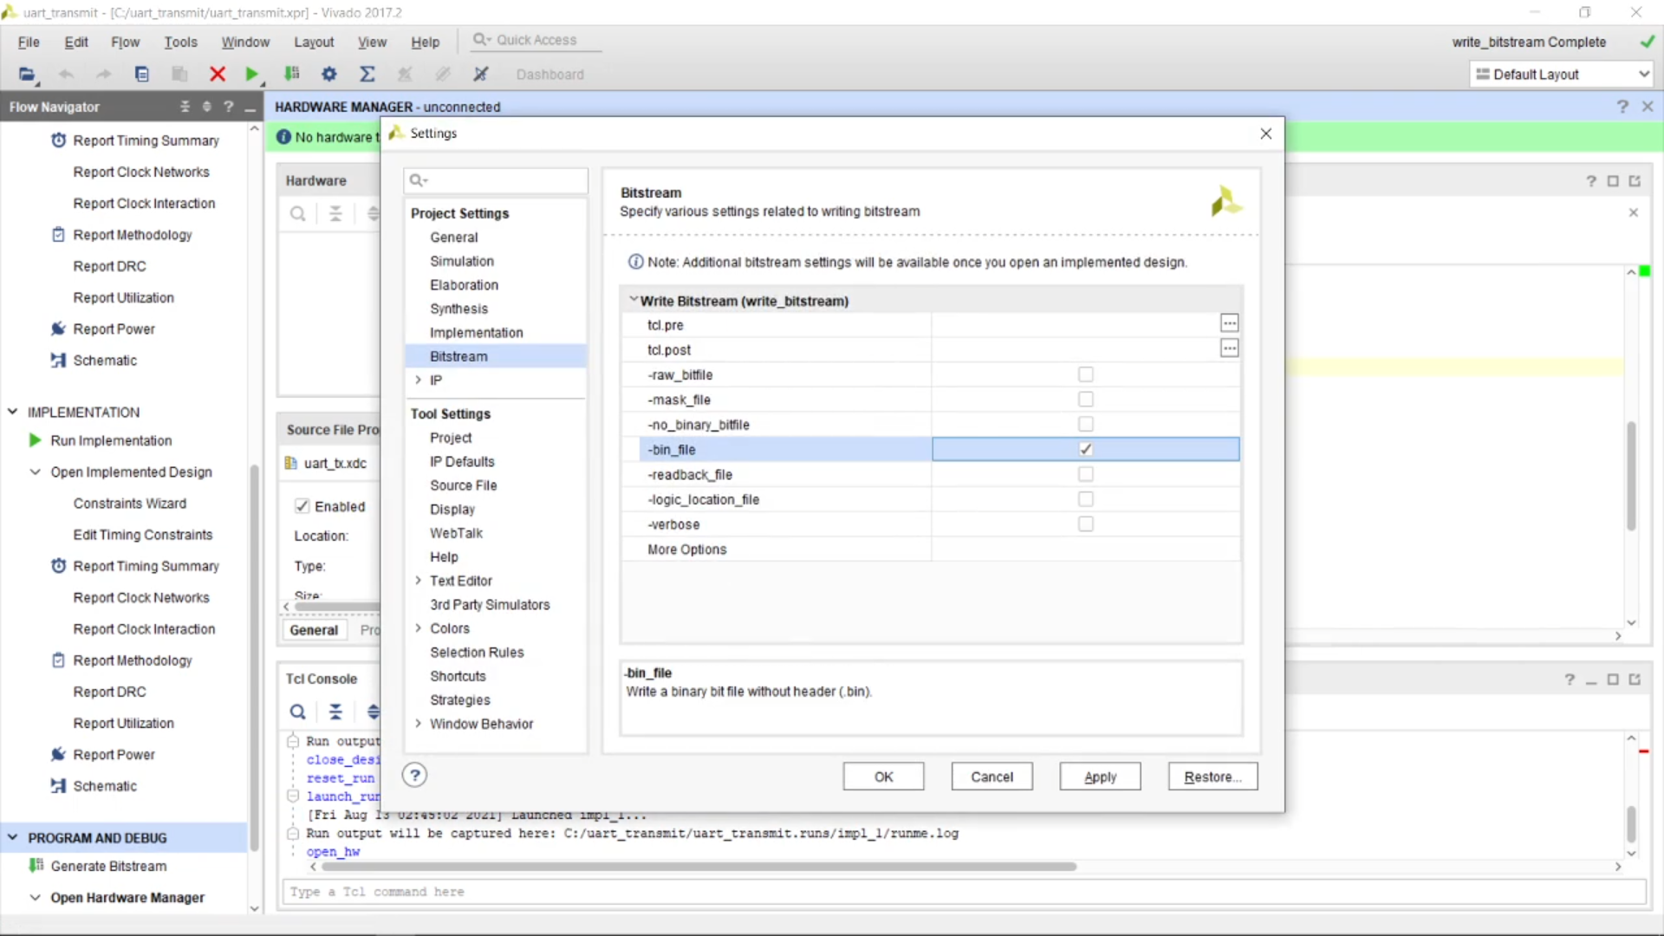After chosing the file select SRAM and run it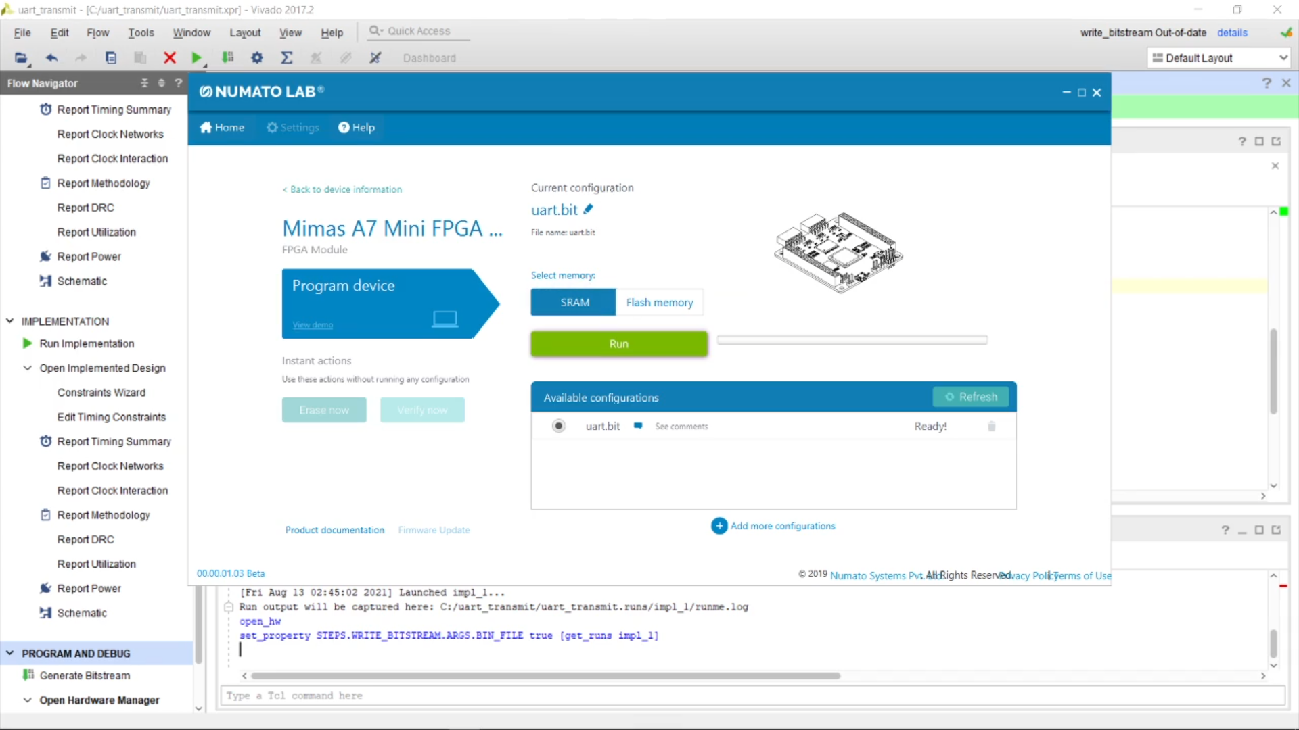

As we know that with push button is enabled with the input of letter we have created so in our case push button will work that way.Every time we press the push button the letter V gets automatically printed in its own.

